# **Airfoil design choices**

Airfoil shape is the design chosen that determines the shape of the wings cross section giving it particular properties that have different advantages in certain conditions depending on the environment the aircraft will fly in. Example below of a labelled airfoil shape:

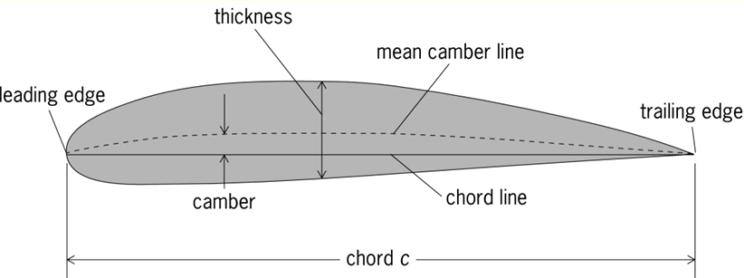Airfoil shape - (https://www.researchgate.net/figure/Airfoil-nomenclature_fig1_357117887)

The environment that the aircraft being designed will fly in is very laminar airflow and not susceptible to large effect factors such as wind gust and rain. With this considered the only major airfoil designed needed to be investigated is ones with a low Reynolds (Re) number (“a low Reynolds number is associated with a laminar flow, which is the preferred flow regime” and “a low Reynolds number is considered to be less than 100,000” - <https://resources.system-analysis.cadence.com/blog/msa2022-low-reynolds-number-airfoil-characteristics> ) and all that work within low airspeeds.

This leaves a few to be picked from when being researched:

* **A18:**

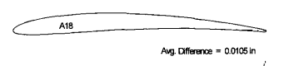/Low-Speed-Airfoil-Data-V1 – P.G. 85)

This airfoil has poor climbing abilities however it also has very good glide abilities which is highly beneficial to the aircraft being designed and in addition to this it has a range of Re of 40k to 300k which means that this airfoil flies very well within laminar flow conditions during straight and level flight and only goes high Re when high angles of attack. In addition to this, the shape of the airfoil is very thin which will save weight in the aircraft overall allow for less lift to be required to keep the aircraft in flight. (P.G. 54 of Low-Speed-Airfoil-Data-V1 & P.G. 86)

* **BE50:**

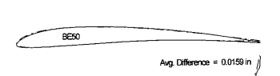(/Low-Speed-Airfoil-Data-V1 – P.G. 91)

This airfoil has a better performance at controlling the changes in drag when dealing with changes to the trim and angle of attack of the aircraft. In addition to this the airfoil shape has a lower overall drag than most of the other airfoil being discussed and has a smoother increase to the drag over time better for endurance flight. However, this is not the conditions that the aircraft beiong design will be in and so this will have to be considered as the flight is a shorter indoor flight. (P.G. 54 of Low-Speed-Airfoil-Data-V1)

* **GM15:**

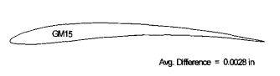 (/Low-Speed-Airfoil-Data-V1 – P.G. 127)

This airfoil has the ability to drastically change the camber to allow for the ability to aid in wither climb or glide which overall allow for versatility. However, with this comes a larger hit to the drag applied onto the glider causing it to need more thrust to make up for this. In addition to this, this is the thinnest airfoil of all being compared and so this will have minimal impact onto the weight and so less lift is required to keep it flying and so weight can be distributed elsewhere to improve structural strength. (P.G. 54 of Low-Speed-Airfoil-Data-V1)

* **MA409:**

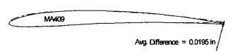(/Low-Speed-Airfoil-Data-V1 – P.G. 149)

This airfoil has very good vertical climb abilities and at which point its Reynolds number is at its highest and so this in turn means that when this airfoil is working at its best is in conditions that the aircraft being designed will not encounter and so this means that this airfoil has less impact onto the aircraft in comparison to others mentioned within this document. (P.G. 54 n 55 of Low-Speed-Airfoil-Data-V1)

* **NACA 6409:**

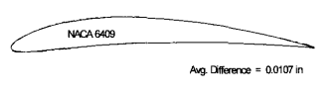(/Low-Speed-Airfoil-Data-V1 – P.G. 167)

This airfoil . However, this is the thickest airfoil of all being compared and so this will impact the weight the most require more lift to keep it flying and in turn may affect the rest of the aircraft. (P.G. 55 of Low-Speed-Airfoil-Data-V1)

**Decision:**

With all of this considered the one that will be chosen for the aircraft being designed will be

**References:**

<https://m-selig.ae.illinois.edu/uiuc_lsat/Low-Speed-Airfoil-Data-V1.pdf> - all notes on the airfoil types

<https://resources.system-analysis.cadence.com/blog/msa2022-low-reynolds-number-airfoil-characteristics> - Reynolds number stats

<https://www.researchgate.net/figure/Airfoil-nomenclature_fig1_357117887> - picture of airfoil